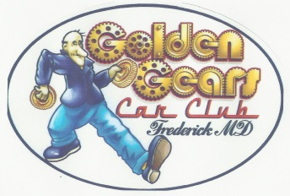
The Golden Gears Car Club
Of Frederick County, MD Inc.
P.O. Box 1583
Frederick, MD 21702

2024 Membership Application

The Golden Gears Car Club of Frederick County, Maryland Inc. is dedicated to the preservation, use and enjoyment of historic, classic, muscle, and special interest vehicles. The club hosts benefit events for charitable organizations and individuals in need within the community. The club organizes cruise-ins, car shows, social gatherings and activities for the enjoyment of Club members.
Benefits of Membership:
- 10% discount at local NAPA Auto Parts Stores
- Club Picnic & Club Christmas Party
- Discount on club apparel
- Membership in one of the area’s oldest active car clubs
- Associate with other car enthusiasts and share knowledge of everything automotive
- Participate in club events such as cruise-ins, parades, fun runs and more

Please complete the following:

- First Name: _______________________ Last Name: __________________________________

- Address: _____________________________________________________________________

- City: _____________________________State: _______________ Zip: __________________

- Cell Phone: _________________________Home Phone: ______________________________

- E-Mail Address: _______________________________________________________________

- Vehicles you own: _____________________________________________________________
- Single Membership $20 __________________ Family Membership $25 ___________________

Please make checks payable to “The Golden Gears Car Club”

Please bring a completed Membership Application along with dues (check or cash) to the next scheduled meeting. All meetings are the first Tuesday of each month beginning at 6:30 PM at the Frederick Elks Lodge. Questions can be directed to the Membership Committee:

Jay Henley 240-372-1753 president@goldengears.org
Bob Eburg 301-676-0219 secretary@goldengears.org

