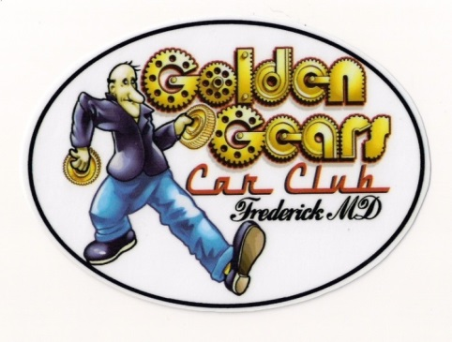
Golden Gears Car Club
of Frederick County Maryland, Inc.
Celebrating 50 Years
P.O. Box 1583
Frederick, MD 21702
Tax ID# 30-0162124

2024 CLUB SPONSORSHIP DRIVE

The Golden Gears Car Club of Frederick County Maryland, Inc., a Maryland Non-Profit 501 (c) (3) Corporation is seeking Annual Sponsors for 2023. The club was formed in 1973 and 2023 is our 50th Anniversary. We are dedicated to the preservation, use and enjoyment of historic, classic, muscle, and special interest vehicles.

The club hosts, sponsors and participates in Car Shows, Cruise-Ins, Parades, Bingos, Dances and many other fundraising events. These fundraising events help support local charitable organizations, veterans’ groups, scholarships and individuals in need within Frederick County Maryland.

An annual sponsor can be an individual, group, organization or business who wishes to contribute $200. By contributing this tax deductible amount for the year, the Golden Gears Car Club will provide the following:
- Your name or logo on our club t-shirt (you will receive up to 2 free shirts)
- A plaque with your name recognizing your sponsorship
- An invitation to our annual club picnic
- Your name advertised on the side of our club trailer which appears at all events
- Announcements at our car shows, cruise-ins and events recognizing your sponsorship

If you would like more information about our club please visit www.goldengears.org or contact one of our club officers listed below.
Sponsorship applications and checks should be mailed to the PO Box listed above or contact one of our officers and they will arrange to pick-up your payment in person. Applications & payment is due by March 15, 2024.

Jay Henley, President (301)831-0154 Henleyboard92@msn.com
Debbie Locke, Vice President (301)801-1329 debbie.locke@comcast.net

2024 GOLDEN GEARS CAR CLUB SPONSORSHIP

Sponsor Name:

Contact Name:

Website: __________________________________________________________________

Address:

City, State, Zip

Phone Email

Date ____________________ Check # ____________________ Amount ______________________

*** Applications and checks must be received on or before March 15, 2024 ***

